“Trapped in a cell”

YEAR 13 UNIT 5 TEST 3

5.3 REDOX EQUILIBRIA

Answer all questions

Buona fortuna!

Name:………………………………………………………….

Mark for section A…………… /30

Mark for section B…………… /20

Total: ……………………………. /50

Grade……..

SECTION A
1. Use the data below, where appropriate, to answer the questions which follow.
Standard electrode potentials | E/V
2H+(aq) + 2e– → H2(g) | 0.00
Br2(aq) + 2e– → 2Br–(aq) | +1.09
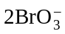(aq) + 12H+(aq) + 10e– → Br2(aq) + 6H2O(l) | +1.52
Each of the above can be reversed under suitable conditions.
(a) State the hydrogen ion concentration and the hydrogen gas pressure when, at 298 K, the potential of the hydrogen electrode is 0.00 V.
Hydrogen ion concentration ......................................................................................
Hydrogen gas pressure ..............................................................................................
(2)
(b) The electrode potential of a hydrogen electrode changes when the hydrogen ion concentration is reduced. Explain, using Le Chatelier’s principle, why this change occurs and state how the electrode potential of the hydrogen electrode changes.
Explanation of change ...............................................................................................
.....................................................................................................................................
Change in electrode potential ....................................................................................
(3)
(c) A diagram of a cell using platinum electrodes X and Y is shown below.
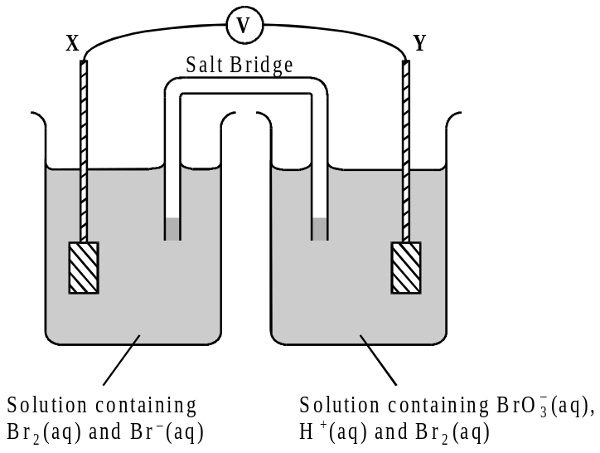
(i) Use the data above to calculate the e.m.f. of the above cell under standard conditions.
...........................................................................................................................
(ii) Write a half-equation for the reaction occurring at electrode X and an overall equation for the cell reaction which occurs when electrodes X and Y are connected.
Half-equation ...................................................................................................
Overall equation ..............................................................................................
...........................................................................................................................
(4)
(Total 9 marks)

2. Use the data given below, where appropriate, to answer the questions which follow.
Standard electrode potentials in acid solution E/V
Mg2+ (aq) + 2e– → Mg(s) –2.37
Zn2+ (aq) + 2e– → Zn(s) –0.76
Sn4+(aq) + 2e– → Sn2+(aq) +0.15
VO2+(aq) + 2H+(aq) + e– → V3+(aq) + H2O(l) +0.34
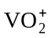 (aq) + 2H+(aq) + e– → VO2+(aq) + H2O(l) +1.02
Ce4+(aq) + e– → Ce3+(aq) +1.70
(a) Give the components of the standard reference electrode used in determining the standard electrode potentials above. State the conditions under which this standard reference electrode has a potential of 0.00 V.
Components.................................................................................................................
.....................................................................................................................................
.....................................................................................................................................
Conditions...................................................................................................................
.....................................................................................................................................
.....................................................................................................................................
(6)
(b) A diagram of a cell is shown below.
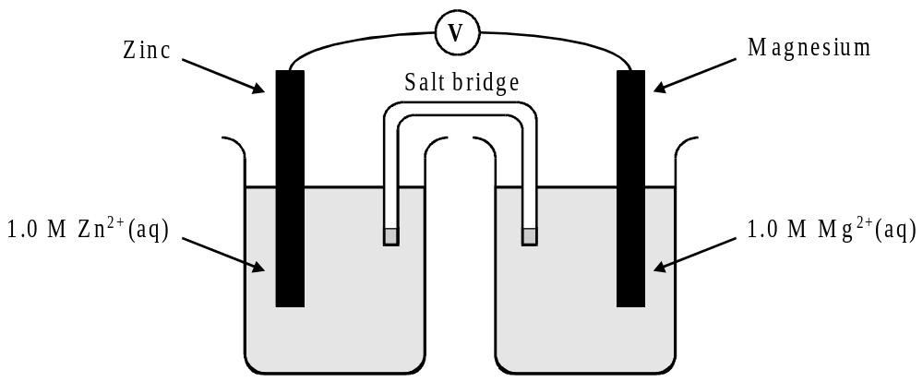
(i) Calculate the overall standard potential of this cell.
...........................................................................................................................
(ii) State the polarity of the zinc electrode.
...........................................................................................................................
(2)
(c) A diagram of a cell is shown below.
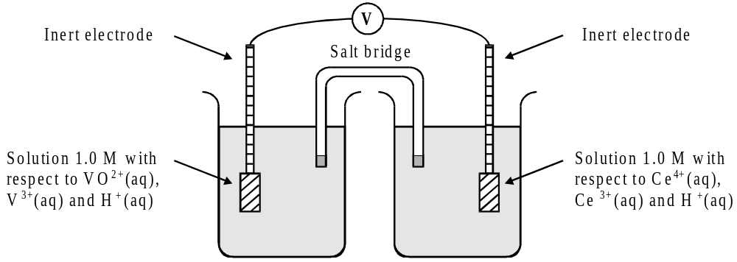

(i) Calculate the overall standard potential of the cell.
...........................................................................................................................
(ii) Deduce the direction of electron flow in the external circuit when the inert electrodes are connected together.
...........................................................................................................................
(2)

(d) Using data from the table on page 6, derive an equation for the overall redox process which occurs when a solution containing Ce4+,(aq) is added to a solution containing
V3+ (aq).
.....................................................................................................................................
.....................................................................................................................................
.....................................................................................................................................
.....................................................................................................................................
(3)
(e) Which, if any, of the four vanadium-containing species, V2+ (aq), V3+ (aq), VO2+ (aq) and VO2+ (aq), will convert Sn2+(aq) into Sn4+ (aq) in acid solution?
.....................................................................................................................................
(2)
(Total 15 marks)

3. Where appropriate, use the standard electrode potential data in the table below to answer the questions which follow.
 |  |  |  |  |  |  | Eο/V
Zn2+(aq) | + | 2e– | → | Zn(s) |  |  | –0.76
V3+(aq) | + | e– | → | V2+(aq) |  |  | –0.26
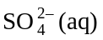+ 2H+(aq) | + | 2e- | → | 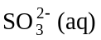 | + | H2O(l) | +0.17
VO2+(aq) +2H+(aq) | + | e– | → | V3+(aq) | + | H2O(l) | +0.34
Fe3+(aq) | + | e– | → | Fe2+(aq) |  |  | +0.77
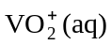+ 2H+(aq) | + | e– | → | VO2+(aq) | + | H2O(l) | +1.00
Cl2(aq) | + | 2e– | → | 2Cl–(aq) |  |  | +1.36

(a) From the table above select the species which is the most powerful reducing agent.
.....................................................................................................................................
(1)
(b) From the table above select
(i) a species which, in acidic solution, will reduce to VO2+(aq) but will not reduce VO2+(aq) to V3+(aq),
...........................................................................................................................
(ii) a species which, in acidic solution, will oxidise VO2+(aq) to 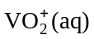.
...........................................................................................................................
(2)
(c) The cell represented below was set up under standard conditions.
Pt|Fe2+(aq), Fe3+(aq)||Tl3+(aq),Tl+(aq)|Pt Cell e.m.f. = + 0.48 V
(i) Deduce the standard electrode potential for the following half-reaction.
Tl3+(aq) + 2e– → Tl+(aq)
...........................................................................................................................
...........................................................................................................................
(ii) Write an equation for the spontaneous cell reaction.
...........................................................................................................................
(3)
(Total 6 marks)

SECTION B
4. (a) Electrode potentials are measured using either a primary standard or a secondary one. Name the primary standard and explain why a secondary standard is normally used.
By writing all relevant equations and stating essential experimental conditions, outline how the standard electrode potential, E, for the formation of metallic iron from aqueous iron(II) ions could be measured in a cell using the primary standard. Justify the need to exclude air while this measurement is being made.
(12)
(b) Use the standard electrode potential data given below to predict the direction of spontaneous reaction in
(i) an equimolar solution of iron(II) and iron(III) ions in the presence of metallic iron
(ii) an equimolar solution of gold(I) and gold(III) ions in the presence of metallic gold.
Write equations and calculate e.m.f. values to explain your answers.
(8)
 | E/V
Fe3+ (aq) + 3e– → Fe(s)  Fe2+ (aq) + 2e– → Fe(s)  Au3+ (aq) + 3e– → Au(s)  Au+ (aq) + e– → Au(s) | –0.04  –0.44  +1.40  +1.69
(Total 20 marks)

……………………………………………………………………………………………………………………

……………………………………………………………………………………………………………………

……………………………………………………………………………………………………………………

……………………………………………………………………………………………………………………

……………………………………………………………………………………………………………………

……………………………………………………………………………………………………………………

……………………………………………………………………………………………………………………

……………………………………………………………………………………………………………………

……………………………………………………………………………………………………………………

……………………………………………………………………………………………………………………

……………………………………………………………………………………………………………………

……………………………………………………………………………………………………………………

……………………………………………………………………………………………………………………

……………………………………………………………………………………………………………………

……………………………………………………………………………………………………………………

……………………………………………………………………………………………………………………

……………………………………………………………………………………………………………………

……………………………………………………………………………………………………………………

……………………………………………………………………………………………………………………

……………………………………………………………………………………………………………………

……………………………………………………………………………………………………………………

……………………………………………………………………………………………………………………

……………………………………………………………………………………………………………………

……………………………………………………………………………………………………………………

……………………………………………………………………………………………………………………

……………………………………………………………………………………………………………………

……………………………………………………………………………………………………………………

……………………………………………………………………………………………………………………

……………………………………………………………………………………………………………………

……………………………………………………………………………………………………………………

……………………………………………………………………………………………………………………

……………………………………………………………………………………………………………………

……………………………………………………………………………………………………………………

……………………………………………………………………………………………………………………

……………………………………………………………………………………………………………………

……………………………………………………………………………………………………………………

……………………………………………………………………………………………………………………

……………………………………………………………………………………………………………………

……………………………………………………………………………………………………………………

……………………………………………………………………………………………………………………

……………………………………………………………………………………………………………………

……………………………………………………………………………………………………………………

……………………………………………………………………………………………………………………

……………………………………………………………………………………………………………………

……………………………………………………………………………………………………………………

……………………………………………………………………………………………………………………

……………………………………………………………………………………………………………………

……………………………………………………………………………………………………………………

……………………………………………………………………………………………………………………

……………………………………………………………………………………………………………………

……………………………………………………………………………………………………………………

……………………………………………………………………………………………………………………

……………………………………………………………………………………………………………………

……………………………………………………………………………………………………………………

……………………………………………………………………………………………………………………

……………………………………………………………………………………………………………………

……………………………………………………………………………………………………………………

……………………………………………………………………………………………………………………

……………………………………………………………………………………………………………………

……………………………………………………………………………………………………………………

……………………………………………………………………………………………………………………

……………………………………………………………………………………………………………………

……………………………………………………………………………………………………………………

……………………………………………………………………………………………………………………

……………………………………………………………………………………………………………………

……………………………………………………………………………………………………………………

……………………………………………………………………………………………………………………

